|  |  |  |  |  |  |
| --- | --- | --- | --- | --- | --- |
| TYPE USB | NAME | COLOR | YEAR DEVELOPMENT | SPEED | NOMINAL SPEED |
| **USB 1.0** | **Low Speed** | **White** | **1996** | **1 MB/s** | **1,5 Mbit/s** |
| **USB 1.0** | **Full Speed** | **White** | **1996** | **1 MB/s** | **12 Mbits/s** |
| **USB 2.0** | **Hi-Speed** | **Black** | **2011** | **40 MB/s** | **480 Mbit/s** |
| **USB 3.0** | **Superspeed** | **Blue** | **2011** | **300 MB/s** | **5000 Mbit/s** |
| **USB 3.1** | **Superspeed+** | **Blue Green / Purple** | **2014** | **900 MB/s** | **10 Gbit/s** |
| **USB 3.2** | **Superspeed ++** | **USB – C** | **2017** | **2000 MB/s** | **10 - 20 Gbit/s** |
| **USB 4** | **Superspeed +  Thunderbolt 3** | **USB – C** | **2019** | **4500 MB/s** | **20 – 40 Gbit/s** |
| **USB-BC 1.2** | **USB Battery Charging** |  |  |  |  |
| **USB-PD** | **USB Power Delivery** |  |  |  |  |
| **USB 2.0 / USB 3.0** | **Sleep or Standby Charging capable** | **Yellow** | **2011** | **40/300 MB/s** | **480/5000 Mbit/s** |
| **USB 3.0** | **Sleep or Standby Charging capable** | **Orange** | **2011** | **300 MB/s** | **5000 Mbit/s** |
| **USB 3.1 / USB 3.2** | **Sleep or Standby Charging capable** | **Red** | **2011** | **900/2000 MB/s** | **10 – 20 Gbit/s** |

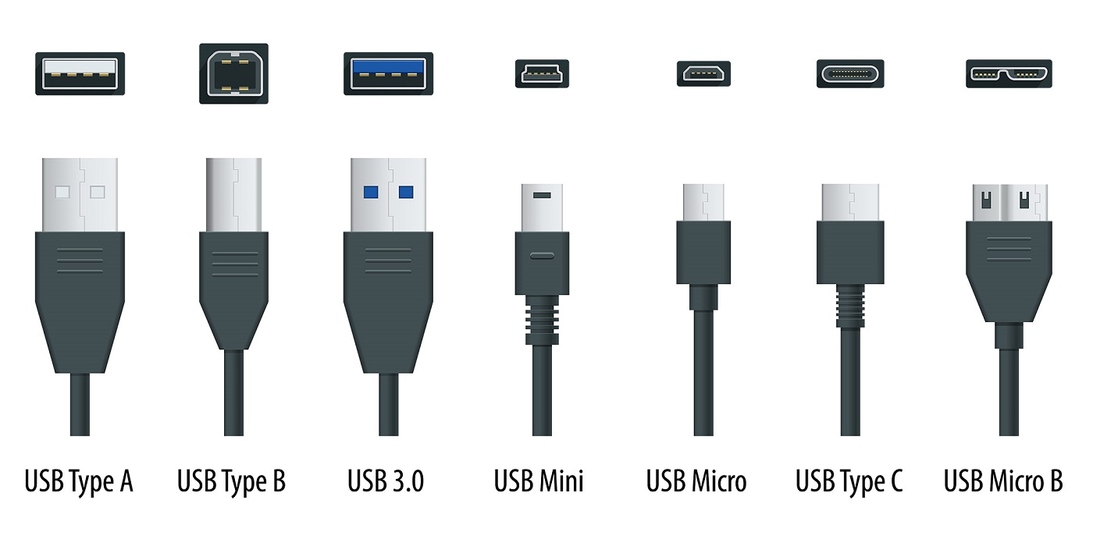

|  |
| --- |
| SB POORTEN |

|  |  |  |  |  |  |
| --- | --- | --- | --- | --- | --- |
| **USB MINI** | | | | | |
|  | PIN | NAME | COLOR | DESCRIPTION | |
| **1** | **VVC** | **RED** | **+5 VDC** | |
| **2** | **D-** | **WHITE** | **Data -** | |
| **3** | **D+** | **GREEN** | **Data +** | |
| **4** | **ID** | **NON-COLOR** | **OTG ID** | |
| **5** | **GND** | **BLACK** | **Ground** | |
| USB MICRO | | | | | |
|  | PIN | NAME | COLOR | DESCRIPTION | |
| **1** | **VVC** | **RED** | **+5 VDC** | |
| **2** | **D-** | **WHITE** | **Data -** | |
| **3** | **D+** | **GREEN** | **Data +** | |
| **4** | **ID** | **NON-COLOR** | **OTG ID** | |
| **5** | **GND** | **BLACK** | **Ground** | |
| **USB - B** | | | | | |
|  | PIN | NAME | COLOR | DESCRIPTION | |
| **1** | **VVC** | **RED** | **+5 VDC** | |
| **2** | **D-** | **WHITE** | **Data -** | |
| **3** | **D+** | **GREEN** | **Data +** | |
| **4** | **GND** | **BLACK** | **Ground** | |
|
| **USB - B** | | | | | |
|  | PIN | NAME | COLOR | DESCRIPTION | |
| **1** | **VVC** | **RED** | **+5 VDC** | |
| **2** | **D-** | **WHITE** | **Data -** | |
| **3** | **D+** | **GREEN** | **Data +** | |
| **(4)** | **ID** | **NON-COLOR** | **OTG ID** | |
| **4** | **GND** | **BLACK** | | **Ground** |

|  |  |  |  |
| --- | --- | --- | --- |
| **USB-C** | | | |
|  | | | |
| **PIN** | **NAME** | **COLOR** | **DESCRIPTION** |
| **A1** | **GND** | **WHITE** | **Ground** |
| **A2** | **TX1+** | **BLUE** | **Superspeed differential pair 1, TX, positive** |
| **A3** | **TX1-** | **YELLOW** | **Superspeed differential pair 1, TX, negative** |
| **A4** | **VBUS** | **RED** | **Bus Power** |
| **A5** | **CC1** | **BLACK** | **Configuration channel** |
| **A6** | **D+** | **GREEN** | **Differential pair 1, positive (Data1 +)** |
| **A7** | **D-** | **WHITE** | **Differential pair 1, negative (Data1 -)** |
| **A8** | **SBU1** | **NO-COLOR** | **Side Band Use (SBU)** |
| **A9** | **VBUS** | **RED** | **Bus power** |
| **A10** | **RX2-** | **PURPLE** | **Superspeed differential pair 4, RX, negative** |
| **A11** | **RX2+** | **ORANGE** | **Superspeed differential pair 4, RX, positive** |
| **A12** | **GND** | **WHITE** | **Ground** |
| **B12** | **GND** | **WHITE** | **Ground** |
| **B11** | **RX1+** | **YELLOW** | **Superspeed differential pair 2, RX, positive** |
| **B10** | **RX1-** | **BLUE** | **Superspeed differential pair 2, RX, negative** |
| **B9** | **VBUS** | **RED** | **Bus power** |
| **B8** | **SBU2** | **NO-COLOR** | **Side Band Use (SBU)** |
| **B7** | **D-** | **WHITE** | **Differential pair 2, negative (Data2 -)** |
| **B6** | **D+** | **GREEN** | **Differential pair 2, positive (Data2 +)** |
| **B5** | **CC2** | **BLACK** | **Configuration channel** |
| **B4** | **VBUS** | **ROOD** | **Bus Power** |
| **B3** | **TX2-** | **ORANJE** | **Superspeed differential pair 3, TX, negative** |
| **B2** | **TX2+** | **PAARS** | **Superspeed differential pair 3, TX, positive** |
| **B1** | **GND** | **WHITE** | **Ground** |